RBFFS Call
Wed, Mar 6, 2019 1:00 PM - 2:00 PM MST
Agenda:
- Roll call (GoToMeeting screen capture) (10 min)

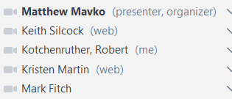
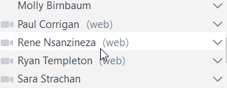
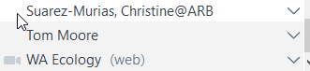

- Note taker: Bob Kotchenruther

- Matt Mavko – presentation slide deck attached to meeting invite (35 min)
- Matt walked through slide deck.

- After slide 8 – Matt stops for questions.
  - Tom – should the slide deck be converted to a white paper?
  - Matt – yes can do, but suggests coalescing white paper around key questions. Askes for agreement.
  - Sara – yes. Also likes using existing data and methods to free up time and resources to focus on key questions. Want to see literature behind slide deck.
  - Matt – for literature, can everyone use google drive? No dissent.
- Back to slides.

- Questions & Discussion after slide deck (10 min)
- Matt – should he send out a survey on key questions – to ask for suggestions & concerns, so people have time to digest info in slide deck?
- Molly (AK) – For developing multi-year means – wouldn’t want to put highest fire years in there – based on AK experience.
- Matt – will look into AK info that was sent.
- Tina – likes eco regional approach – likes idea of looking at 2014 to see whether it was typical or not – Question: Will Rx fire vs. Ag. be treated same in projections – Ag is in same place, Rx changes, wild changes. Need to look and treat each type differently.
- Matt – For projections, each will be treated differently. Ag. maybe held constant. He wouldn’t lump Ag in with Rx. Tina agrees.
- Tom – FLM comments?
- Mark F. – Agrees with Matt and Tina. Likes ecosystem-by-ecosystem approach. Don’t group all together in forecast approach.

- Next call
- March 19, 11 – 12:30 pm MDT
- Combined call with Fire and Smoke Workgroup

- Action Items:
  - Re-read Matt’s presentation from call (https://drive.google.com/open?id=1aSLRaSCBofoeRbctsQ9Wp3Q3yV8atxBV) and prepare answers to his questions.
  - Read materials of interest posted on Google Drive site.

